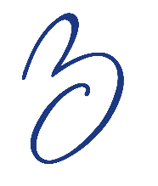
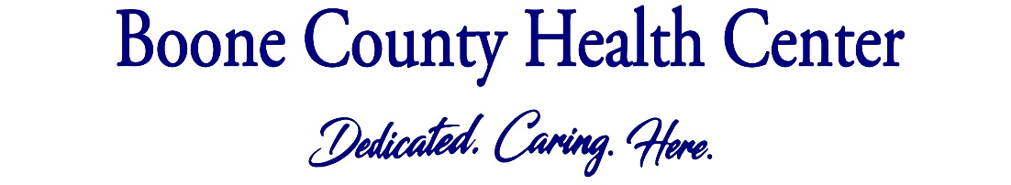

SPORTS PHYSICAL
Your daughter/son will be having a sports physical this year. Here’s what to expect:
Vaccines. Your child will get any necessary vaccines recommended by the Centers for Disease Control and Prevention (CDC). Please note, if your child is on Medicaid or you have no insurance, make sure you come to the clinic in Albion for vaccines. Families with private insurance can get vaccines at any of our clinics.
Exam. We will check a urine sample and do a basic eye exam. We will also check for other health issues, just as we did at checkups when your child was younger.
Talk. We will talk with your child about sleep, physical activity, nutrition, relationships, decision making and more.
What to Bring:
- Your school’s sports physical form – filled out
- Immunization records for review
- Glasses and contacts if you have them
- Full bladder – so we can get a urine sample
- Bottles of medication for review
- Insurance card if you have one
- Filled out Registration and Vaccine Consent Forms (pick up in advance at clinic or download and print from www.boonecohealth.org under Patient Resources and General Info) *ONLY needed if coning without parent. A parent is preferred.
When to schedule: The sooner the better as the schedule gets full fast and your child will need this physical in order to start practicing sports.
How to schedule: Call your local clinic to schedule a sports physical:

Boone County Medical Clinic: 402-395-5013
Cedar Rapids Medical Clinic: 308-358-0615
Elgin Veterans’ Medical Clinic: 402-843-5910
Nance County Medical Clinic: 308-536-2446
Newman Grove Medical Clinic: 402-447-6214
Spalding Medical Clinic: 308-497-2485
St. Edward Medical Clinic: 402-678-2232

